CYBERCAFE MANAGEMENT SYSTEMS VERSION 2.0

TABLE OF CONTENTS

Statement of Agreement 2
Credits and References 2
Introduction 2
Program Features 2
Windows and Explanation 2
Server Section 2
About Window 3
Main Window 3
Usage Section. 4
Charges Window 5
Analysis Report Form 6
Explanation of the Listed Report 6
Client Section 8
Installation Procedure 9
Setting Up 11
Server Set Up 11
Setting up the display 12
Client Set Up 12
Database Browsing 12
Feedback 13

Statement of Agreement

This program is a proprietary of LangNet Enterprise 2000. Any reduplication or redistribution of this program is strictly prohibited. By purchasing this program you are prohibited to make copies and distribute it without written consent of LangNet Enterprise. LangNet Enterprise will not be held responsible with any system whether Window 95, Window 98 or Window NT corruption. This program did not hold any hidden viruses and do not have any damaging program toward user operating systems. LangNet Enterprise will also held no responsibility on usage without proper schedule stated in this document. By following the procedures in this document, there should be no problem occurs with this program.

Credits and References

Systems Design and documentation’s………………………………………………...Iskandar Hussein
Coding improvements………………………………………………………………...Wan Hasnibi
Marketing Strategy and Packaging…………………………………………………...Iskandar Hussein.
Security and License………………………………………………………………….Wan Hasnibi
Prototyping and Design Improvement………………………………………………..Iskandar Hussein.
Logistic and Local Marketing………………………………………………………..Chok Keri.
Web Design and Electronic Marketing………………………………………………Zaidi Dohat.

Introduction

The CyberCafe Management System is a utility that monitors the usage of each client. It is a simple program that records all the usage and collection of a cyber café. There are two parts in this program set. One is the client set and the other is the server set. The client set is stored in the client PC while the server set is stored in the PC Server. Both set need to be installed in order for the program to run. This document will explain in detail on identifying some of the features that this program can offer and how to utilize this program at utmost usage.

Program Features

- To sets of setup disks, client and server disk.
- Able to establish connection and show the connection status with colors toggling of “Status” label.
- Able to handle up to 9 unit of client PC. Higher amount of units of PC needs additional user license.
- Capable to lock client PC. It will only lock the monitor, not the CPU.
- Capable to calculate usage time and release charges of client usage.
- Capable to analyze the collection according to daily, monthly and yearly collection.
- Designed to run on Windows 95/98. With minimum of 32 MB RAM and 15MB free space.
- Could be run on any 1997 and above made processors. Tested on Pentium 166,Pentium III and AMD K6-450.

Windows and Explanation

We will discuss this segment into 2 section, the server section and client section.

Server Section
In this server section there is 4 windows that will appear in the chronological order. Each window will activate once other windows been deactivated. Each window performs different functions. Below are the explanations of each window:

About Window

This about window is the startup window, every time this program executed, this splash screen window appear first. The contents of this about window are:

- The product name. The product name of this program is CyberCafe Management Systems.
- The version number. This tells the user of the revision that has been done.
- The copyright. This program is the copyright of LangNet Enterprise in the year 2000.
- The description. The window explains the description of the program.
- Systems Information.

This window will only appear until you click OK button on the form. Once you hit the OK button, this window will be deactivated and another window will come to the screen. The name of this window is the main window.

Main Window

This main window has two sections. License Registration Sections and Usage Section.

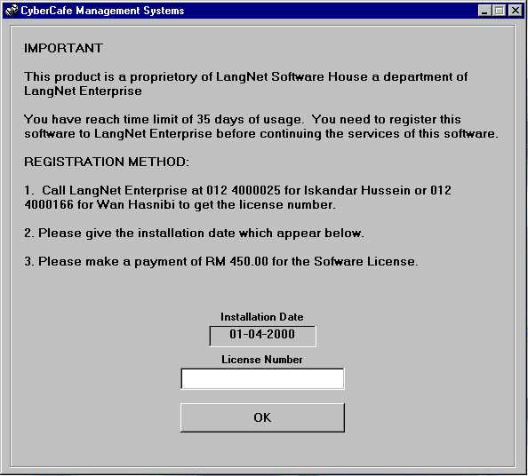
- License Registration Sections

The window will show once the program resides in the hard disk for 35 days without license number. When this happen, call the number stated on the window for Iskandar Hussein or Wan Hasnibi for the release of the valid license number. Remember to make payment of RM 450.00 before you get the license. The license is only for 9-user license. The charge for each client is RM 50.00. The license for more than 9 client together with the patch program will be release once you make payment for the license. As to make the package interesting. The client license of more than 9 client will be given a discount of RM 30.00 for each license in addition to the 9 client licenses. Do not forget to mention the installation date to get the valid license.

Once you entered the user license, hit OK to move to the usage window.

Usage Section.

The usage section is the main window that will be use heavily by the user. The preliminary program will come as 9-client license. More the 9-client license is available upon request. Below is the display of the usage section.

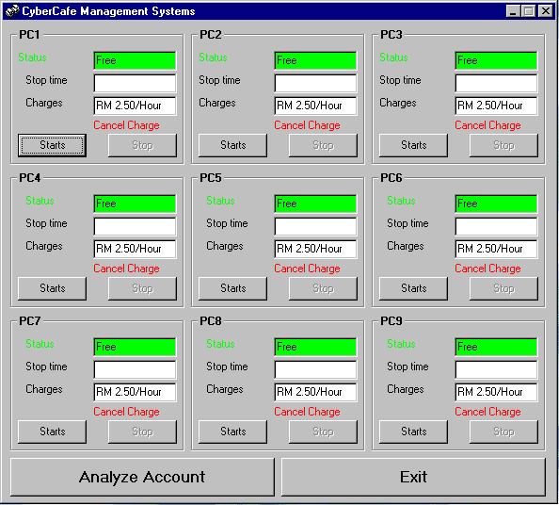

This is the layout of the usage window. The top title will display the “CyberCafe Management Systems”
Below are the features on this window:
- 9 Client Frame starting from PC1 and ended with PC9 (PC number is user setting).
- In each Client Frame (can be set to enable or disable), below are the features:
- PC name: PC name is the number of PC available for monitoring.
- Start Button
By clicking on the start button or client double click on moving icon on client lock page, the current time will be captured and label caption change from “Status” to “Start Time”.
- Stop Button
By clicking on the stop button the current time will be captured and another window will appear stating the current usage and charges of the client ant the display for the client PC will be lock.
- Cancel Charges
Cancel Charges occurs when the customer does not want to use a particular client and want to move to another client or operator doesn’t want to charge the client. By double clicking the “Cancel Charges” label, the charges will be cancel and the display on the client will be lock and no record in database.

- Analyze button to activate the analysis report form window that will display the report for the collection in the way the operator wants to see, whether it is in monthly report, daily and yearly report.
- At each frame, there are labels with caption “Status” and “Stop Time”. When this program running these two captions is green and black in color respectively. When the “Status” is green and “Stop Time” is black, it indicates that the port is open ready for connection to one particular client PC (same port number). When client PC connect to the particular server frame these two captions change from green and black to blue. If connection between client PC and the server frame is alive caption “Status”change color toggling from red to blue every time the server send a signal to the client PC. If “Status” stop toggling color, it indicates connection between client PC and server broken. To restore back connection, firstly double click on “Stop Time” until it change from blue to black then double click on “Status” until it change from blue/red to green. To close the port at server double click on “Stop Time” and the label change to black. To open back the port, double click on “Status” label and the color turned to green.

Charges Window
Charges windows will appear when the user clicked on the stop button. The window will look like this.

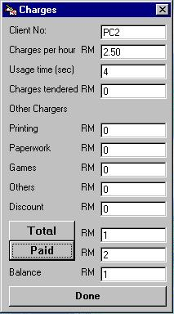
This window features:

- The Client Number that is the PC number.
- Chargers that tendered for an hour (user setting).
- Usage time in a second.
- Chargers tendered for the current usage.
- Printing Chargers, been entered manually by the operator.
- Paperwork chargers, been entered manually.
- Games played charges been entered manually.
- Other usage’s charges that are not stated can be entered in the Others item
- Discount charges with will be minus from the total charges.
- When this window appear Done button is disable, to make this button enable Total button has to be click fist.
- Total button that will display the total chargers and this amount will be write into database.
- Paid button, which will display amount paid by the customer and the display of change to be paid back to the customer.
- Done button to complete the transaction.

In the usage window, there are two button, analyze button and the exit button. If the user clicks the Analyze Button, an analysis report form will appear and the form will be looking like the illustration in below.

Analysis Report Form
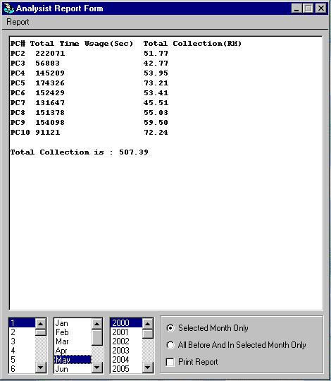

In the analysis report form the display will show type of report below:
- Daily Collection Report
- Monthly Collection Report
- View Usage Log
- Close Account Year.

Explanation of the Listed Report

The first row of the Report pull down menu is the “Daily Collection Report”. Daily Collection Report shows the collection for the selected day. Below are the explanation of each the of the row listed under Report Pull Down Menu.

- At the Report Pull Down Menu choose “Daily Collection”. The example of the method can be seen in the illustration below.
- A listing of collection for the day will appear, as shown in the one illustration below the first illustration.
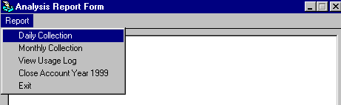
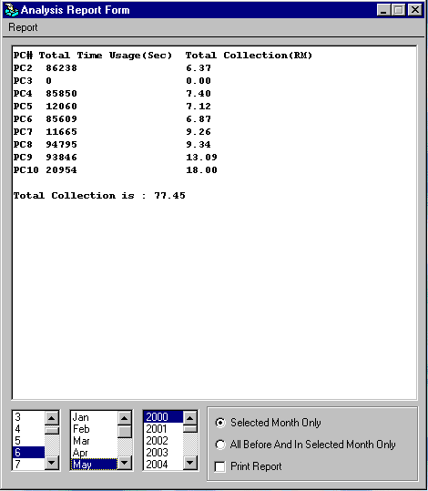
- If you notice in the illustration above at the bottom of the form, there are three listbox listing the day, month and year. To view the collection of specific day, click on the desired date listbox on the leftmost listbox followed by the desired month and year.
- You can also filter the data for selected month only where you only have to click on the option box near the text “Selected Month Only”.
- For the option button with text “All Before And In Selected Month Only”, this utility will display the collection for the selected month and the collection date before the selected date.
- The option box “Print Report” utility will allow for printing. To print, select the button and choose the desired date and choose the option on the report pull down menu. All the display will be printed to the default printer. There is no need to set the printer for particular format. The user has set everything for the ease of use.
- Going back to the upper form, you can also choose monthly report, view the whole log and even close account for the year. The formats of the display are similar to the one shown in the above form.
- Menu Close Account Year 1999 is to create year 1999 collection summarization into file usagelog1999.txt and delete these collection records from database (usagelog.txt). This menu will be disabling once it running and file usagelog1999.txt is not deleted. This utility is for database refreshing and will automatically ask for database refreshing every year.

Note: Do not open Window Explorer and open the usagelog.txt or analyze.txt file while the program is running. The display report will show an empty space if you do that. To solve this problem in the event you opened the usagelog.txt and analyze.txt, is to close the program and restart back the startup process on both server and client side.

The explanation ends the server side, in the next section we will discuss about the client side of the program.

Client Section

The client section involves 2 forms. These two forms are namely, the client form and the login form. There are not much utility available on both forms. The Client form is shown below:
The client form display has only two changeable items. One is Server IP Address and the another is the port number. The sunken label below the Port No: textbox is the indicator for the connection. The label will be filled with the caption “Connected” once the Connect button been clicked. The connection will automatically connect after 10 sec if the Connect button is not clicked. Once the connections alive the window will be minimize and invisible and display-locking window is appearing. Errors will occurs when there is a lose connection between the server and the client. When the occurrence happens, the client form will be displayed as below.

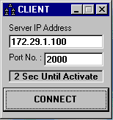
If connection broken this client window will be visible and PC is beeping. Observe the sunken label has a caption “Connection Terminate”. After 5 times beeping the client program will be automatically deactivate. Reason why connection is broken is server program deactivated, port closed and network problem.
Once this occurrence happens, to reconnect back the connection, just click “X” button at the upper right side of the client forms then start the client form once again.
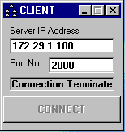
Once the connect button clicked or after 10 seconds, display-locking window will appear. It is just the display that covers the screen. The display has a moving label icon “Double Click On Me To Login”, that need a double click action in order to open up the display for browsing and other computer usage activities.

The display could be change with any picture since it used bitmap picture format. You can also design your own bitmap and change the display design by naming the picture name “lang.bmp”.

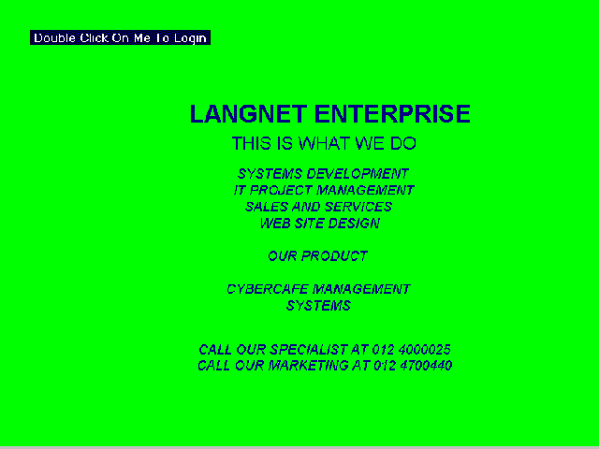
Once the label is double click the display-locking window will be disappear and there will be a working timer at the task bar, client will be able to view their usage during their work on the PC.

Installation Procedure

We have learned about the windows, now we will learn how to install the program.
Below are the steps and procedures:

- There are four disks that come with the installation package.
- Two disks are for the server set and another two are for the client set.
- The server set should be install first followed by the client set.
- Insert floppy disk, which label “Server Disk 1” then double click the “setup.exe” file.
- A Setup window will appear as below.
- The installation filename is CyberCafe Management System setup.
- When the below window appears, click on OK.
- However, make sure that there is no other program that is running at the background. Close all other running application before running this setup program.
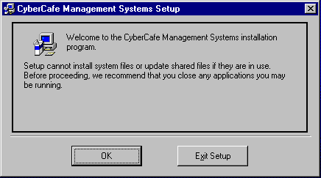
- When the OK button has been clicked, another window will appear. The window will look as below.

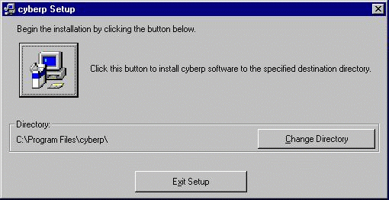
- At this window, you can change the directory location just by clicking the “Change Directory” button or just used the default directory.
- Once you are satisfied with the location, click on the button with the PC icon above.
- Once the icon clicked, the system will continue loading all the executable and dependent files.
- Once every file have been transferred and updated the setup then complete. The complete setup window will appear as below.

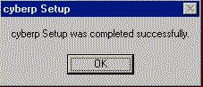

- The running or executable file will be located at the program section of the pop up menu of Windows.
- By Clicking the “CyberCafe Management Systems”, the program will brings you to the main program window.
- Repeat the same with the client set. However, remember not to install the client set in the PC server.
- Client Set should only be installed in the Client PC.

Setting Up
The server program should be run first before running the client program.

Server Set Up

There is file that you need to fill in before starting the program. The filename is “config.txt”. The input that need to be typed are:

- Usage rate for one hour.
- Minimum charges usage less than an hour.
- PC number should have 9 PC all together. Examples 1 to 9 or 2 to 10.
- PC frame to enable or disable. Should have also 9 input. T for enable and F for disable.
- Port Numbers to be use. (These port numbers are preset during the development of this program)

Below are how the input looks like.

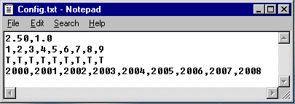
If you notice the figure 2.50 stands for usage rate for one hour. The figure 1.0 is the rate for minimum charges for usage less than an hour. The figures 1 through 9 in second line are PC numbers. The figures in third line are frame-enabling setting. The figures 2000 through 2008 in fourth line are the port numbers.

You only have to change the numbers and save the notepad filename as it is.

You have to set the regional setting which is located under control panel. To activate the setting, go to control panel and choose the regional setting. The regional setting properties window will appear and at the upper tab choose “Date”.

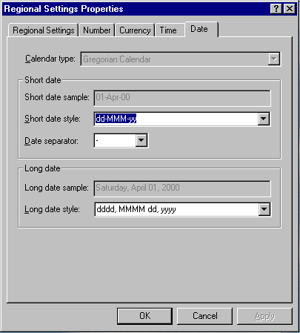
Go to short date text box and change the date format to this format “dd-MMM-yy” View the example for further understanding.

Setting up the display

The display setting for the program to be better presented should be as below.
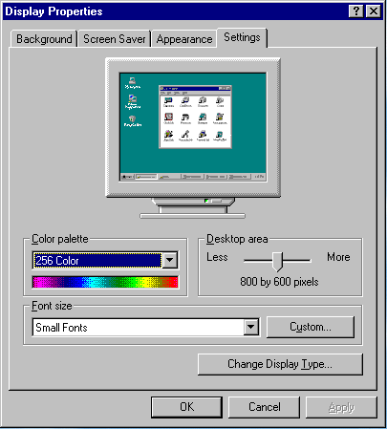

Client Set Up

In client set up there is a filename “svr.txt”. In the file below are the input needed for “svr.txt”:

- PC Server IP Address.
- Client Port Number.

Below is the display for the “svr.txt” file.

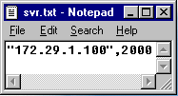
The entry “172.29.1.100” is the IP address of the PC Server. While the figure “2000” is the port number. The port number for each client PC should be different port number. The port number has been set up during the PC Server setup.

Note: All the set up should be done in Window Explorer Environment.

Database Browsing
All the collection made is record in the file name usagelog.txt.

Below is the database sample.

13

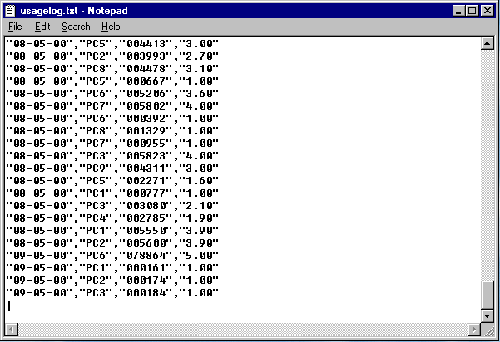
First string is date then PC number then third string is total usage in second and last string is charges. If changes need to be make to the database please make sure there is no empty line and cursor at the fist row on the last line before the file is save.

Feedback

For feedback on the upgrades or improvement feel free to call the developers, Iskandar Hussein and Wan Hasnibi, at 012 4000025 and 012 4000166. User can also join the user group at www.langnet.com.

CYBERCAFE MANANGMENT SYSTEMS

Langnet Enterprise
B-4-4 Sri Idaman Kondominium
Jalan Padang Gaong
07000 Langkawi

Telephone: +6012-4000025
e-mail: isna8627@tm.net.my

Information in this document is subject to change without notice, and does not represent a commitment on the part of Langnet Enterprise.

Microsoft Windows, Microsoft Windows NT, Microsoft Windows 95 and Microsoft Windows 98 are trademarks of Microsoft Corporation.

All trademarks and copyright mentioned in this documentation are the property of their respective owners.

